
SRM Institute of Science and Technology
Mode of Exam
OFFLINE
SET D
College of Engineering and Technology
School of Computing
DEPARTMENT OF COMPUTING TECHNOLOGIES
SRM Nagar, Kattankulathur – 603203, Chengalpattu District, Tamilnadu
Academic Year: 2023-2024 (EVEN)
Test: CLAT-1 Date: 16.02.2024
Course Code & Title: 18CSC305J– Artificial Intelligence Duration: 50 Mins
Year & Sem: III/VI Max. Marks: 25

Course Articulation Matrix:
S.No | Course Outcome | PO1 | PO2 | PO3 | PO4 | PO5 | PO6 | PO7 | PO8 | PO9 | PO10 | PO11 | PO12
 | CO1 | H | M | H | - | - | - | - | - | - | - | - | -
2 | CO2 | H | M | H | - | - | - | - | - | - | - | - | -
3 | CO3 | M | H | H | - | - | - | - | - | - | - | - | -
4 | CO4 | M | H | M | - | - | - | - | - | - | - | - | -
5 | CO5 | M | H | H | M | - | - | - | - | - | - | - | -

Part – A
( 10 x 1 = Marks)
Instructions: Answer all
Q. No | Question | Marks | BL | CO | PO | PI Code
1 | Which of the following is not a heuristic way?  - To discover something or an idea embedded in a program  - To search and measure how far a node in a search tree seems to be from a goal  - To compare two nodes in a search tree to see if one is better than the other is  - Exploring the state space without considering the cost of reaching the goal | 1 | 1 | 1 | 1 | 1.6.1
2 | The extraction of meaningful information that is previously unknown and can be very useful potential ahead is known as  - Knowledge Discovery  - Machine Learning  - Learning Theory  - Neural Computation | 1 | 1 | 1 | 1 | 1.6.1
3 | Which model is based on sign processes or signification and communication?  - Syntactic  - Semantic  - Semiotic  - Statistical | 1 | 2 | 1 | 1 | 1.6.1
4 | The process of removing detail from a given state representation is called  - Extraction  - Abstraction  - Information retrieval  - Mining of data | 1 | 1 | 1 | 1 | 1.6.1
5 | Choose the correct: A) knowledge base (KB) consists of a set of statements. B) Inference is deriving a new sentence from the KB.  - A is true, B is true  - A is false, B is false  - A is true, B is false  - A is false, B is true | 1 | 2 | 1 | 1 | 1.6.1
6 | Treatment given by doctor for a patient to treat a disease is based on.  - Only current symptoms  - Current symptoms plus some knowledge from the textbooks  - Current symptoms plus some knowledge from the textbooks plus experience  - Some knowledge from the textbooks plus experience | 1 | 2 | 1 | 1 | 1.6.1
7 | What happens when the backtracking calculation arrives at a solution?  - It backtracks to the root  - It continues searching for other possible solutions  - It traverses from a different route  - Recursively traverses through the same route | 1 | 1 | 1 | 2 | 1.6.1
8 | Which environment cannot be changed while the agent is deliberating?  - Static  - Stochastic  - internal state  - percept | 1 | 2 | 1 | 2 | 1.6.1
9 | The following diagram is the representation _________ in state space of 4 – queen’s problems.  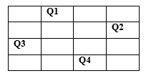  a) Initial state  b) Intermediate state  c) Goal State  d) Path | 1 | 2 | 1 | 1 | 1.6.1
10 | Constraints are the ones that restrict  - Movement  - Arrangement  - Possibilities  - Solutions  - 1,3  - 1,2,3,4  - 2,4  - 1,3,4 | 1 | 2 | 1 | 1 | 1.6.1
Part – B
( 3 x 5 = Marks)
Instructions: Answer any 3
11 | Discuss in detail about the Problem Formulation for Vacuum Cleaner World showing all possible states.  Problem Formulation :  Choosing relevant set of states & feasible set of operators for moving from one state to another.  An Example Problem Formulation  Let us take the example of vacuum world that was introduced in the starting of this series, There is a vacuum cleaner agent and it can move left or right and its jump is to suck up the dirt from the floor.  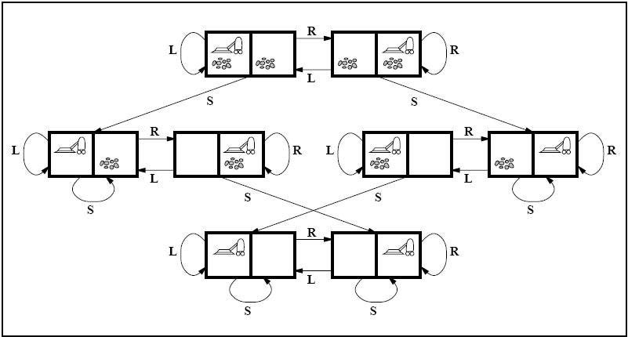  Fig: State space for vacuum world.  The problem for vacuum world can be formulated as follows:  States: The state is determined by both the agent location and the dirt location. The agent is in one of two locations, each of which might or might not contain dirt. Therefore, there are 2 x 2² = 8 possible world states.  A larger environment would have n x 2 to the power of n states.  Initial State: Any state can be assigned as the initial state in this case.  Action: In this environment there are three actions, Move Left , Move Right , Suck up the dirt.  Transition Model: All the actions have expected effects, except for when the agent is in leftmost square and the action is Left, when the agent is in rightmost square and the action is Right and the square is clean when the action is to Suck.  Goal Test: Goal test checks whether all the squares are clean.  Path Cost: Each step costs 1, so the path cost is the number of steps in the path.  The vacuum world problem is a toy problem and involves only discrete locations, discrete dirt etc. | 5 | 3 | 1 | 2 | 1.6.1
12 | Solve the following Cryptarithmetic Puzzle  - EAT + THAT = APPLE (2.5)  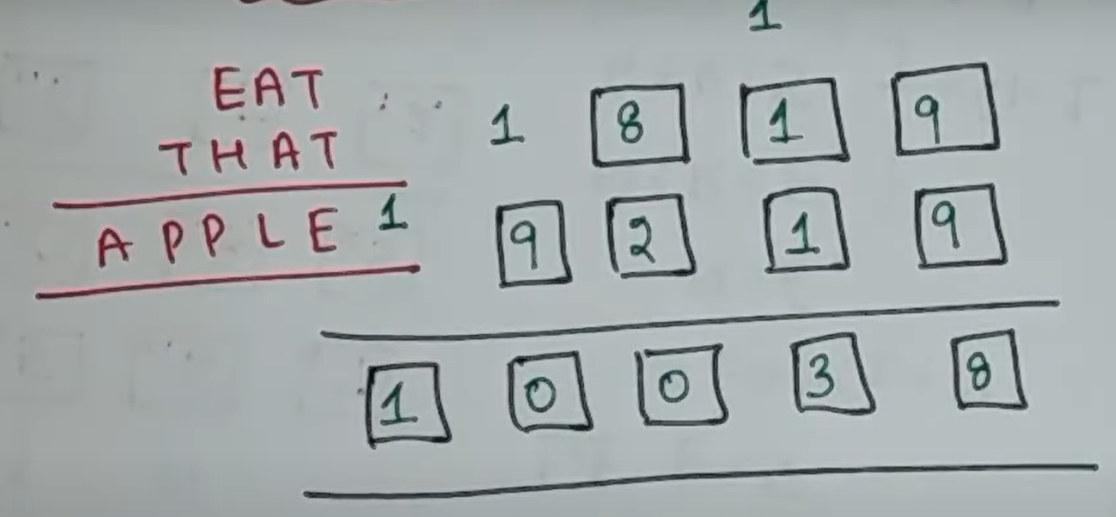  - POINT + ZERO = ENERGY (2.5)  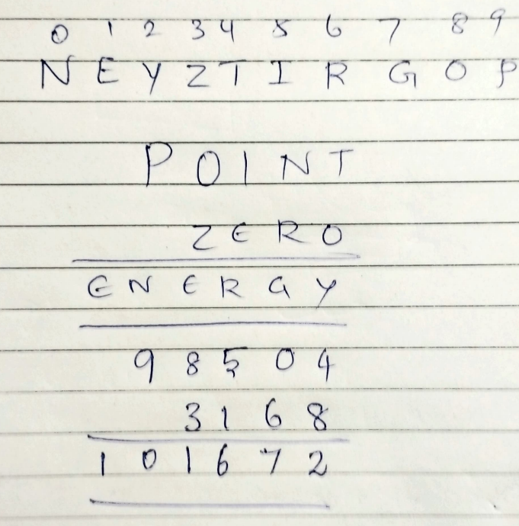 | 5 | 3 | 1 | 2 | 1.6.1
13 | There are three missionaries und 3 cannibals standing on the left bank of a river. A boat is available which can take maximum 2 people at a time. At any point of time number of missionaries should not be outnumbered by cannibals which is fatal. Make a plan to safety take all to the right bank. Represent the above problem by state space search problem  - Represent initial state  - Goal state  - Operators  - Action plan  - Find the entire solution  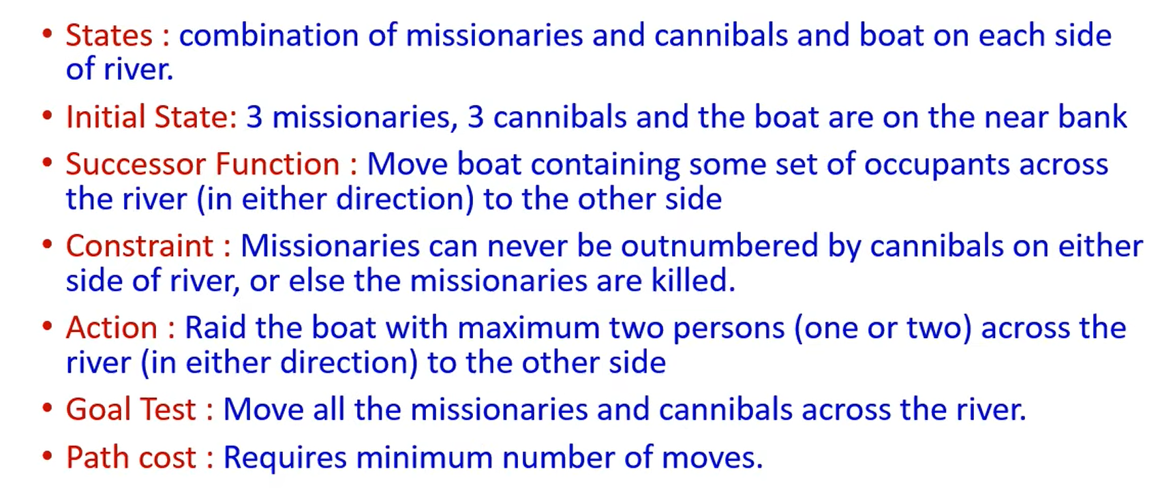  Entire Solution:  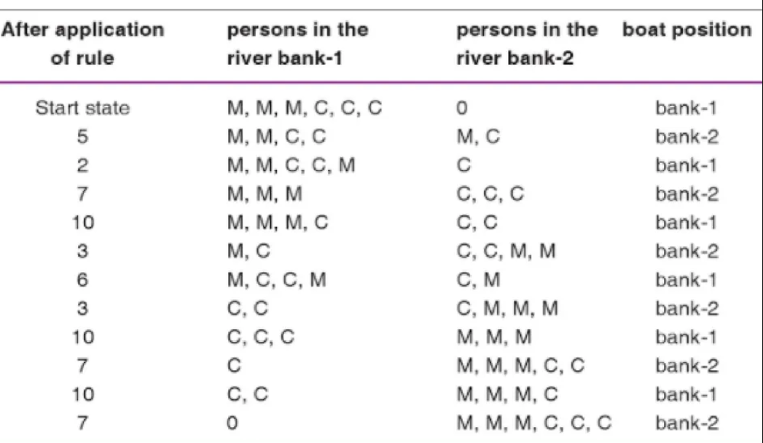 | 5 | 1 | 1 | 1 | 1.6.1
14 | Explain the concept of intelligent backtracking with example.  Explained with N-queen’s example.  ANS: In intelligent backtracking (Backjumping), backtracking is carried out to the most recent variable(MRV) in the conflict set. In case of Forward checking the event is deducted and then the search is restricted from making a move towards such a node or variable. so we can always conclude that the tree branch is pruned by the forward checking will also be pruned by backjumping. Let us consider the example of the four- queens proble. it is clear that with the conflict set, backjumping occurs to Q1 position rather than Q2 while taking decision for Q3. Thus a conflict needs to be deducted by the use of conflict set So that a BackTrack can occur . this type of back jumping where backtracking occurs with the use of conflict sets is referred to as conflict directed backjumping.  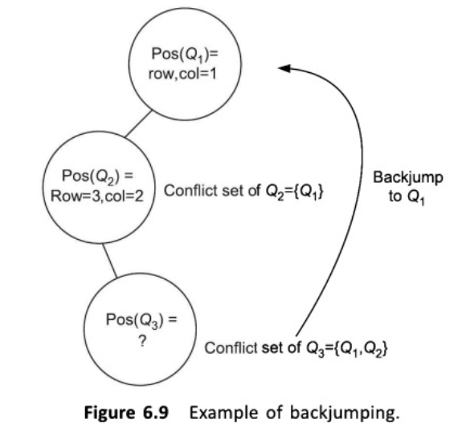 | 5 | 2 | 1 | 1 | 1.6.1

*Performance Indicators are available separately for Computer Science and Engineering in AICTE examination reforms policy.

Course Outcome (CO) and Bloom’s level (BL) Coverage in Questions

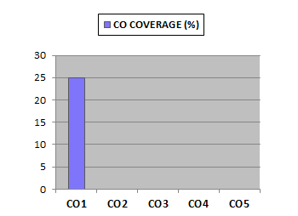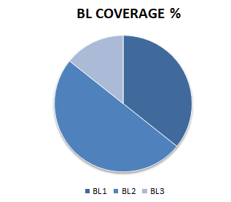

Approved by the Audit Professor/Course Coordinator

